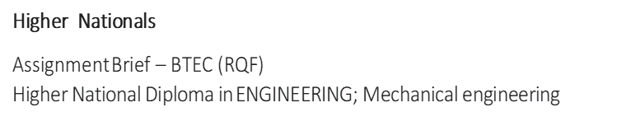

**Designing a CNG System in a Liquid Fuel Gas Station**

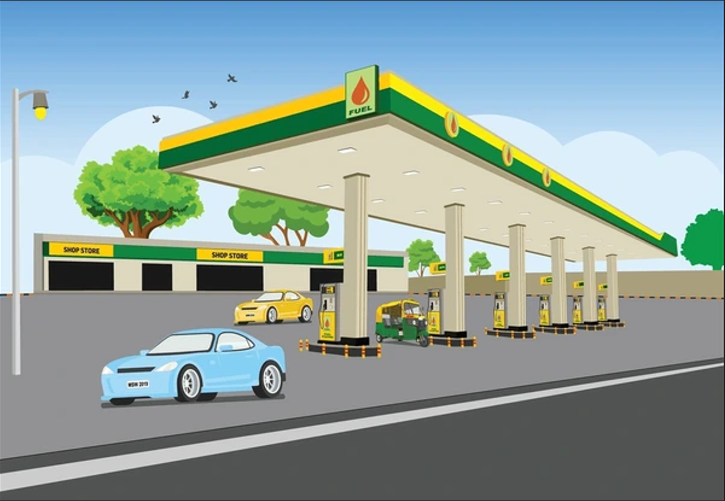

**Student:** Junior Charles / 44712

**Unit:** 4, Managing a Professional Eng. Project

**Academic Year:** 2024 – 2025

**Unit Assessor:** Mr. Russell Ramrattan

**Assignment Title:** Section 1 (S1): Proposal

**Issue Date:** Wednesday 29th January 2025

**IV Name:** Ms. Akina Gordon

**Date:** Tuesday 9th March 2025

**Table Of Contents**

1. Purpose……………………………………………………………….………….2
2. Sustainability Considerations………………………………….………….2
3. Design Phase Success Planning……………………………………..…. 3
4. Project goals and Objectives………………………………………….…. 5
5. Project Deliverables…………………………………………………………. 6
6. Identification of Resource Structure…………………………………… 6
7. Estimated Cost of Project…………………………………………………. 7
8. General Scope of Work……………………………………………………… 8
9. Engineering Scope………………………………………………………….. 12
10. Schedule of Activities and Gantt chart……………………………….. 13
11. Feasibility Study…………………………………………………..…………..15
12. Political and legal constraints in Legislation and Ethics ………….17
13. Political, Economic, Social, Technological, Legal, Environment.18
14. References……………………………………………………………………..20
15. Appendix ………………………………………………………………………..22

**List of tables**

Table 1*…………………………………………………………………… Cost estimation*

Table 2…………………………………………………………………… *Financial Feasibility & Life Cycle Cost Analysis*

Table 3……………………………………………………………………Laws and engineering standards

# **1.Purpose**

Trinidad and Tobago’s heavy reliance on petroleum-based fuels has led to significant greenhouse gas emissions and rising fuel costs. This proposal aims to increase the demand for compressed natural gas (CNG) fueling at service stations across the country for vehicle use. The transportation sector’s high demand for diesel and gasoline contributes substantially to air pollution. By modifying systems at individual gas stations, such as the one located in Erin, we can increase both the volume of fuel distributed and the number of vehicles refueled daily.

Compared to other fuel alternatives, CNG is much cleaner, reducing carbon monoxide emissions by up to 80%, and is more cost-effective. CNG is a clear, non-corrosive, and odorless gas, which can be stored safely in vehicles, extending the driving range while causing less wear and tear on the engine.

In terms of cost, CNG is nearly one-third the price of gasoline (super), with a rate of $3.58 per liter, allowing consumers to save up to 68%. Premium gasoline and diesel are priced at $5.75 and $2.30 per liter, respectively, offering savings of up to 82% and 42%, respectively, when using CNG.

**2.Sustainability Considerations**

Sustainability is a key focus throughout every phase of the project, from design to construction. The objective is to minimize environmental impact, ensure long-term cost-effectiveness, and promote energy efficiency.

Incentives

* In Trinidad and Tobago, motor vehicle taxes and VAT are removed on imported vehicles (manufactured to use CNG) under two years of age. People who are willing to convert their vehicles to CNG would receive 25% on a limit of $10,000. (loop news 2017)

Economic Benefits

* If citizens switch to CNG, the money spent by the Government on Trinidad and Tobago on the fuel subsidy (Super, Diesel and Premium) can then be relocated to other sectors which may need funding. Foreign exchange can also be generated by selling the liquid fuels which aren’t being used. (loop news 2017)

**3. Design Phase Success Planning**

Sustainability in the Planning and Design Process: The project will incorporate the latest technological advancements in CNG technology, such as efficient pressure regulators, leak detection systems, and eco-friendly components, to improve durability and ensure long-term sustainability.

Time estimate: This design timeline is expected to take three (3) months for completion, which also allows adequate time for proper planning, testing, and validation of the system before procurement begins.

Design Team: The unique crew of personnel will contain skilled engineers who will be specialize in sustainable fuel, environmental and safety advisors, and supply chain and logistic officers, which will be responsible, accountable and guidance for ensuring practices throughout the project.

Interpretation of the Brief: This design shall place priority for the integration of a modern, high-efficiency CNG dispensing system, ensuring compatibility and precision with the current infrastructure. Infrastructure to be in place for future upgrades and modifications without hampering the current framework.

Pricing: with the budget in mind, a cost analysis was done to ensure the selected materials and components are financially purchased but also not compromising the integrity of the asset.

Design and Development Considerations: The project will include high-efficiency gas compression units C-15.2 MDi CNG Compressor 767, energy-efficient lighting, and an advanced monitoring system to reduce emissions and waste. Additionally, noise reduction measures will be implemented to minimize disturbances to the surrounding community.

**A. Procurement: Economies of Scale and Sustainable Sourcing**

The procurement strategy is essential to ensuring the project’s cost-efficiency and environmental responsibility.

**Sustainable Products:** The project will prioritize suppliers offering environmentally friendly materials, such as corrosion-resistant storage tanks with longer lifespans and energy-efficient compression units.

**Economies of Scale:** Acquiring necessary components like compressors, storage tanks, and dispensers in bulk will help lower costs while reducing packaging waste.

**Buying Local:** Where possible, buy locally sourced components which will minimize transportation emissions and support the local economy.  
**Supplier Vetting:** Procurement policies will include thorough environmental and ethical screening of suppliers to ensure alignment with sustainability goals.

**B. Construction Phase: Efficiency in Construction**

Construction Methods and Site Management: Best practices during an efficient construction method shall be adopted, such as pre-fabricating key components to reduce on-site waste. The construction site will be carefully managed with strict waste disposal policies to prevent environmental contamination.

The construction phase will prioritize efficiency, durability, and environmental responsibility. Reliable construction methods will be used to minimize wastage, enhance energy usage, and decrease the environmental impact.

**Workmanship and Quality Control**: High-quality workmanship is mandatory to ensure a solid foundation. Thorough quality control measures will be implemented to mitigate against all risks of leakage or mechanical failure that can harm people, environment and the asset.

**Identifying and Repair of abnormalities**: A proactive approach will be adopted to manage and defects found on this system backed up with extensive testing conducted during and after construction to identify and resolve any issues.

**Material Supply Considerations**: Weather-resistant materials will be used to ensure longevity, particularly in components exposed to outdoor conditions. Additionally, non-toxic materials will be prioritized to avoid contamination risks.

**Weather-Resistant Materials and Methods**: Considering the climate of Trinidad and Tobago, materials will be selected for their ability to withstand high temperatures, humidity, and extreme weather. Protective coatings will be applied to extend the equipment lifespan and reduce maintenance requirements.

**On-Site Energy Efficiency**: Construction equipment will be chosen for its energy efficiency, and power consumption will be minimized by utilizing renewable energy sources, such as solar-powered lighting for the construction sites.

**4) Project goals and Objectives**

The main goal of this project is to develop and install a efficient and sustainable CNG dispensing system at the Erin Gas Station. This will improve accessibility, promote environmental responsibility, and reduce fuel costs.

**Objectives:**

* To design and install two dispensing stations capable of refueling four CNG-equipped vehicles simultaneously.
* To ensure adherence to local and international environmental and safety standards.
* To incorporate sustainable design, procurement, and construction practices to minimize environmental impact.
* To promote long-term energy savings and enhance operational efficiency.
* To create an infrastructure model that can be replicated at other fuel stations across the country.
* To engage key stakeholders, including government agencies, private investors, and the public, in adopting cleaner fuel alternatives.
* To provide training for station personnel and raise public awareness of the benefits of using CNG.

**5) Project Deliverables**

This project will depend highly and contribute to Trinidad and Tobago’s sustainability goals and energy security.

**Key Deliverables:**

* **Fully Functional CNG Dispensing System:** Two dispensing stations will be installed and tested, capable of servicing four CNG-equipped vehicles simultaneously.
* **Sustainable Design Implementation:** The integration of energy-efficient compressors, automated monitoring systems, and eco-friendly materials.
* **Regulatory Compliance Documentation:** A comprehensive assessment to ensure the system meets both national and international safety and environmental standards.
* **Feasibility and Cost-Benefit Analysis Report:** A detailed analysis of operational costs, projected savings, and long-term economic benefits.
* **Training Program for Operators and Technicians:** A structured training program for station personnel to ensure safe and efficient operation.
* **Risk Assessment and Mitigation Plan:** A thorough strategy for identifying and addressing potential risks related to CNG storage, distribution, and usage.
* **Expansion Framework for Future Stations:** A strategic plan for replicating the CNG system design at additional fueling stations across the country.

**6) Identification of Resource Structure**

The positive outcome will depend on the personnel skill set:

Labor Requirements:

* **Project Manager**: In charge and accountable for achieving all key deliverables ensuring adherence to timelines and budget.
* **Design Engineers**: Responsible for designing the system, while meeting all standards for mechanical, electrical and structural regulations.
* **Construction Workers & Technicians**: Skilled personnel required for the installation of piping, compression units, and dispensing systems.
* **Electrical Engineers**: Manage wiring, automation, and the integration of monitoring systems.
* **Safety Officers**: Ensure the system complies with national and international safety standards.
* **CNG System Operator**: Experts in gas compression and distribution, ensuring the system operates efficiently.

Training Personnel: Provide training for station staff on system operation, maintenance, and emergency procedures.

Material Requirements:

* **High-Pressure CNG Storage Tanks:** Ensure the safe storage of compressed natural gas before distribution.
* **Dispensing Units:** Two dispensing stations capable of refueling four vehicles simultaneously.
* **Gas Compressors:** Essential for maintaining the required pressure levels for CNG distribution.
* **Regulators & Flow Control Valves:** Ensure accurate gas flow control and safety measures.
* **Piping and Fittings:** Stainless steel and corrosion-resistant pipes to securely transport the gas.
* **Electrical Components:** Control panels, sensors, and automation systems for monitoring and safety functions.
* **Leak Detection Systems:** Vital for identifying and preventing gas leaks.
* **Protective Enclosures & Safety Equipment:** Fire suppression systems, emergency shutdown controls, and appropriate signage.

Equipment Requirements**:**

* **CNG Compressors:** High-efficiency units designed to compress natural gas.
* **CNG Storage Cylinders:** Certified cylinders for the high-pressure storage of CNG.
* **Gas Dispensers:** User-friendly, automated dispensers for accurate and efficient fueling.
* **Monitoring and Control Systems:** Sensors, automated alarms, and digital interfaces for system monitoring.
* **Testing and Calibration Tools:** Pressure gauges, flow meters, and gas analyzers for system verification and calibration.

**7) Estimated Cost of Project.**

|  |  |  |  |
| --- | --- | --- | --- |
| Category | Unit Cost EUR | Requirement | Estimated Cost (EUR) |
| Project Manager | 340/ hr. | 100hrs | 34000 |
| Design Engineers | 200/ hr. | 200hrs | 50000 |
| Construction Workers & Technicians | 120/ hr. | 500hrs | 72000 |
| Electrical Engineers | 150/ hr. | 175hrs | 35250 |
| Safety and Compliance Officers | 100/hr. | 250hrs | 50000 |
| CNG System Specialists | 230/hr. | 100hrs | 23000 |
| Training Personnel | 100/ hr. | 48 | 3600 |
| High-Pressure CNG Storage Tanks | 50000 | 2 | 100000 |
| Dispensing Units | 40000 | 2 | 80000 |
| Gas Compressors | 120000 | 2 | 240000 |
| Regulators & Flow Control Valves | 3500 | 8 | 28000 |
| Piping and Fittings | 25000 | Per Eng. Design | 25000 |
| Electrical Components | 23000 | Per Eng. Design | 23000 |
| Leak Detection Systems | 20000 | Per Eng. Design | 20000 |
| Protective Enclosures & Safety Equipment | 45000 | Per Eng. Design | 45000 |
| Monitoring and Control Systems | 50000 | Per Eng. Design | 5000 |
| Testing and Calibration Tools | 15000 | Per Eng. Design | 19000 |
| TOTAL INSTALLED COST (TIC) |  |  | 907850 |

*Table 1* *Cost estimation*

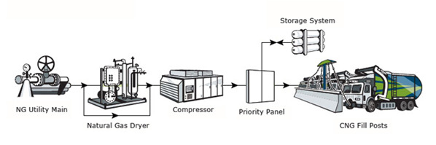

**8) General Scope of Work**

The scope of work for the installation of a CNG refueling station at Erin Gas Station encompasses site selection, system design, procurement, installation, testing, and commissioning. The project aims to integrate a sustainable and high-efficiency CNG dispensing system into the existing liquid fuel infrastructure.

**A. Site Selection**

* **Identify Location:** Select an existing liquid fuel station in Erin that can accommodate a CNG refueling system.
* **Desktop Site Assessment:** Use Google Earth to assess space availability, accessibility, and safety considerations.
* **On-site Assessment:** Conduct a physical visit to observe the fueling station, analyze customer flow, traffic patterns, and assess the feasibility of CNG integration.

**B. Determination of Natural Gas Supply**

* **Pipeline or LNG Assessment:** Assess gas supply method (pipeline connection from the existing cross-island gas pipeline or LNG delivery via road tanker).
* **Feasibility of Pipeline Integration:** Assess the proximity of the gas station to an existing natural gas pipeline for direct supply.
* **Storage and Logistics Considerations:** If LNG is the chosen supply method, design on-site storage solutions for gas conversion.

**C. CNG Refueling Station Components**

The station will be designed based on industry standards to ensure safe and efficient CNG dispensing.

CNG Systems in Automobiles**:**

* + **CNG Kits & Tanks:** Vehicles using CNG will be retrofitted with high-pressure tanks.
  + **Pressure Considerations:** Ensure the station provides gas at appropriate pressures (typically 200-250 bar for vehicle refueling).
  + **Fuel Tank**-Stores compressed natural gas for vehicle use. The tanks should be made of steel or a composite material to withstand up to 4000 psi (strength and durability). It should be inspected on the date specified.
  + **Fuel Lines** -Transfers the fuel from the tank to the engine. These lines should be designed to handle the required pressures of the system.
  + **Pressure Regulator**-Decreases the pressure from the tank so it can be usable for the engine’s fuel injection system. These regulators should be inspected on a scheduled basis.
  + **Manual Shutoff Valve** -In case of emergency, this valve can be shut off. This should be made easily accessible for users.
  + **Internal Combustion Engine** -The engine is modified to use the CNG as the fuel source when the gasolene is locked off. Increasing the use of CNG will increase the health of the engine.

CNG Systems for Refueling Stations**:**

* + **Metering & Regulator Station:** Essential for controlling and monitoring the incoming gas flow.
  + **Compressors:** soundproof casing at noise level at 75 dB, Pressure Range3.0~20.0 MPa and Capacity 400 Nm3/h~2200 Nm3/h. The natural gas is received through pipelines, pressurize it within the station, and directly fills compressed natural gas into CNG vehicles or stores it in fixed gas bottle banks (wells). These compressors would consume less energy therefore being cost effective. Being efficient will also contribute to a cleaner environment. Also take into consideration that these units are reliable, and maintenance costs would be at their lowest, making operations economical

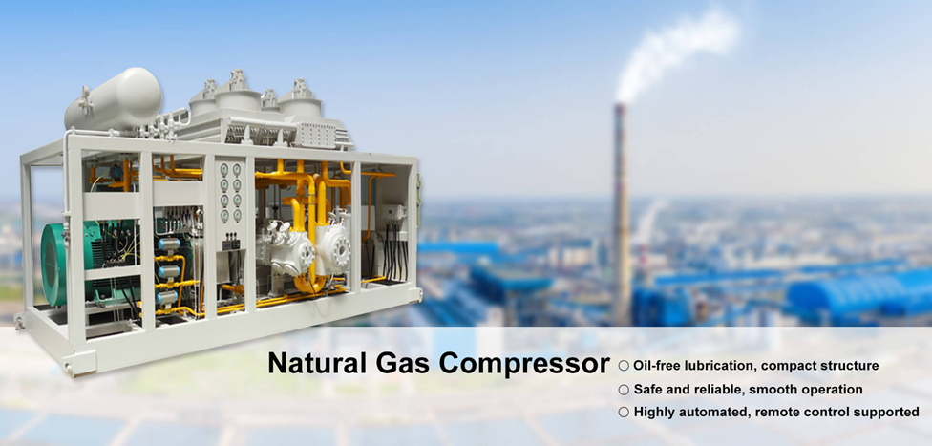

* + **Storage Tanks:** Has a capacity of 12,115 SCF at 5500 psi. Designed to requirements ASME Section VII, Division 2 (national Board registration .2vessels are stacked horizontally on top each other (85 inches total) which utilizes the space occupied by the system High-pressure gas cylinders or buffer storage to ensure a continuous supply during peak demand. Increasing the tanks will allow more capacity for the condensate, which will reduce the frequency of refilling and would create a consistent supply, which means longer runtime without downtime. These larger tanks are designed with advanced safety features which would reduce the risk of leaks. A close-up of several white tubes

    AI-generated content may be incorrect.
  + **Dispensers:** Eight dispensers capable of filling four CNG-equipped vehicles simultaneously. Increase the number of dispensers (8 fast filled dispensers) Model:

C-15.2 MDi CNG Compressor 767. Benefits (cngcenter n.d.)

This type of dispenser will be able to have a small fleet operation.  
 It can operate from our local utility gas company (NGC) via direct connection 0-5 PSI it delivers 19/40 SCFM.

* + Features
  + can compress the gas up to 4500 PSI
  + compressor unloading system
  + 4 stage compressors
  + Heavy duty 15 HP electric motor, 120/240 VAC, 2 PH /
  + 30HP, 460 VAC, 3PH
  + low gas temperatures are maintained by a built-in cooler
  + Belt driven and is easily aligned
  + Each interstage is equipped with Safety relief valve
  + filters located on the inlet and discharge
  + Pressure monitoring

* Hose and breakaway connections- This coupling is installed between the dispenser and hose. It is designed in the event a vehicle is driven from the dispenser with nozzle still in the fuel port, the coupling will separate, elimination any harm or damage to persons or property. (WEH 2025) Pressure range = 250 bar (3,600 psi) | PS = 350 bar, Material Corrosion resistant stainless steel, aluminum, Temperature range-40 °C up to +85 °C

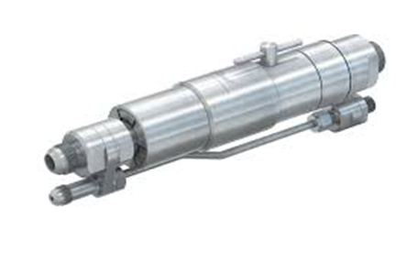

**D. Installation & Integration**

* **Site Preparation:** Clear and prepare the site for CNG infrastructure installation.
* **Installation of Compressors, Tanks, and Dispensers:** Ensure safe and secure installation according to industry’s best practices.

**E. Testing, Commissioning & Safety Checks**

* **System Pressure Testing:** Verify that all components operate under required pressure conditions without leaks.
* **Safety Protocol Implementation:** Ensure emergency shut-off valves, leak detection systems, and fire suppression mechanisms are fully operational.
* **Regulatory Inspections:** Conduct inspections to ensure compliance with local and international safety and environmental standards.
* **Final System Commissioning:** Conduct operational tests and quality assurance checks before the station is fully operational.

**F. Training & Handover**

* **Personnel Training:** Provide training for pump attendance on CNG refueling procedures, troubleshooting, and safety protocols.
* **Station Handover & Operational Launch:** Perform a final review and approval before the official commissioning for public use.

**G. Assumptions and Capacity Planning**

* The station is designed to serve at least 200 CNG vehicles per day.
* The compressor system will have a minimum output of 500 standard cubic feet per minute (SCFM) to support simultaneous vehicle refueling.
* Storage tanks will maintain adequate pressure (200-250 bar) to prevent refueling delays.
* LNG-based supply will only be considered if pipeline gas is unavailable within a 1-kilometer radius of the station.
* The CNG station will be operational 24 hours a day, with dispensers capable of serving four vehicles simultaneously.

This scope ensures that the installation of the CNG refueling station is comprehensive, efficient, and aligned with both operational goals and environmental standards.

**9)Engineering Scope**

Engineering Deliverables for MET CNG: Engineering drawing list for MET CNG project

Mechanical and Piping drawings: Isometric Piping drawings, Piping general arrangement or layout, sections, elevations, details for metering/regulator station, compressor, storage tanks and dispensers.

**10)Schedule of Activities and Gantt chart**

* + - * Bottom of Form

A project schedule is crucial for the successful planning, execution, and completion of a project. The schedule for this project is divided into three key phases: Proposal, Report, and Presentation.

The Gantt Chart (Appendix 1) is essential for effective project planning, execution, and monitoring.

* Tracking Progress – This clearly outlines tasks' start and end date, so a timeline is established.
* Task Management: It helps in breaking down the project into smaller, manageable tasks, and shows the sequence in which these tasks need to be completed.
* Dependency Tracking: Illustrate task dependencies, highlighting which tasks need to be completed before others can begin, which helps in identifying potential bottlenecks.
* Progress Monitoring: By updating the chart with actual progress, project managers can easily track the status of each task and the overall project, identifying any delays or issues.
* Resource Allocation: It aids in planning and allocating resources efficiently, ensuring that the right resources are available at the right time.
* Communication: Gantt charts serve as an excellent communication tool, providing a clear and concise way to share the project plan and progress with stakeholders.
* Deadline Management: They help in setting and managing deadlines, ensuring that the project stays on track and is completed on time.

**Schedule Breakdown:**

1. Proposal (January 6th- February 14th)
   * + - Restate Problem and Select Project Solution (Jan 13th – Jan 26th) 2 Weeks
       - Conduct Secondary Research (Jan 20th- Jan 26th) 1 Week
       - Design Project Plan (Jan 27th – Feb 9th): 2 Weeks
       - Perform Feasibility Study (Feb 3rd – Feb 16th) 2 Weeks
       - Determine Legislation Ethics on Decision Making (Feb 3rd – Feb 16th) 2 Weeks
       - Prepare Logbooks Weekly (Jan 6th – April 20th) 15 Weeks
2. Report (February 17th- April 6th)
   * + - Conduct project activities (Feb 17th – Mar 2nd) 2 weeks
       - Explore alternative solutions planned (Feb 24th – Mar 9th) 2 weeks
       - Critically evaluate own behaviors, make recommendations for improvement (Feb 24th – Mar 23rd ) 1month
       - Prepare and execute primary research- questionnaire (Mar 17th – Mar 30th) 2weeks
       - Analyze and prepare discussion Mar 24th Apr 6th)2 weeks
       - Prepare project report (Mar 17th – Apr 6th)2 weeks
3. Presentation (April 7th – April 20th)
   * + - Select and prepare appropriate method for audio visual presentation (Apr 14th – Apr 28th)
       - Challenges and value gained (Apr 14th – Apr 20th)
       - Success of project and justified improvements (Apr 7th- Apr 20th)
       - Self-reflection on own performance (Apr 7th- Apr 20th)

***See Appendix A***

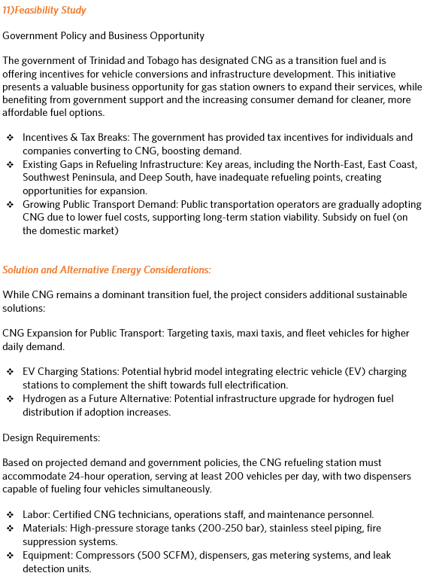

* The availability of Natural Gas supply

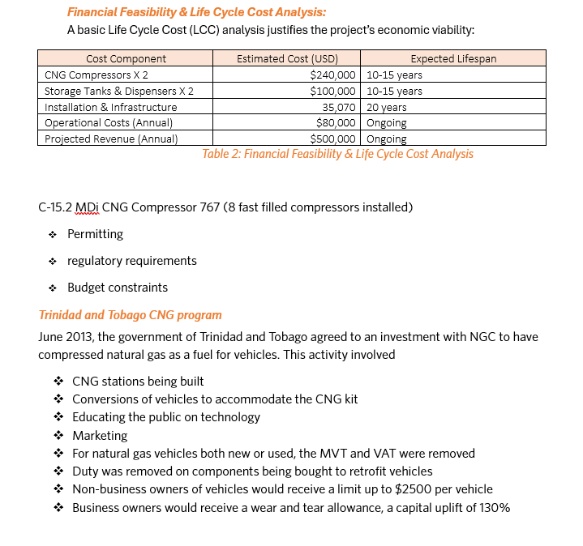

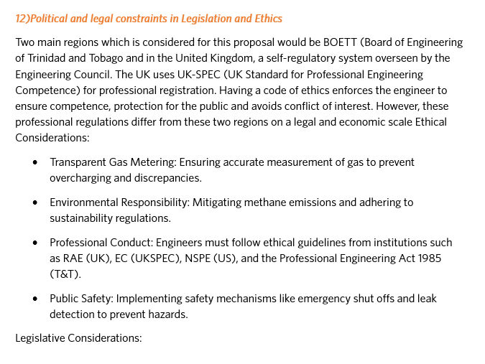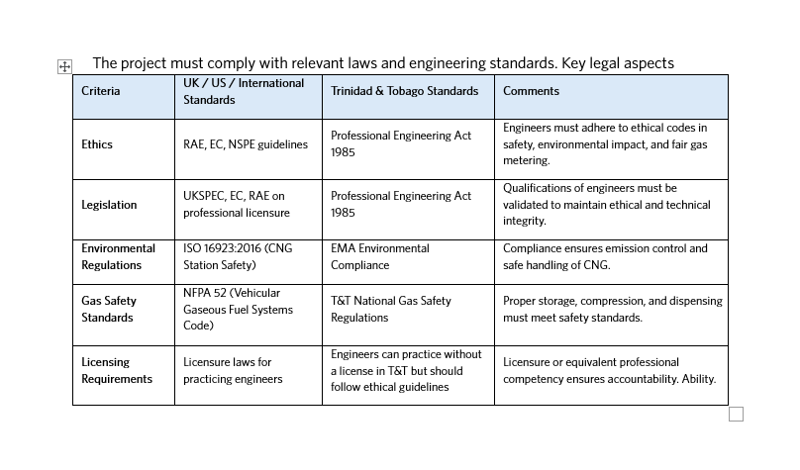



* 1. ***(Political, Economic, Social, Technological, Legal, Environment)***

A PESTLE analysis is a strategic tool used to understand the external factors that can impact an organization. The acronym stands for:

* **Political**: Examines how government policies, regulations, and political stability affect the business environment. This includes tax policies, trade restrictions, and political stability.
* **Economic**: Looks at economic factors such as inflation rates, interest rates, economic growth, and exchange rates. These factors influence purchasing power and cost structures.
* **Social**: Considers social factors like cultural trends, demographics, population growth rates, and lifestyle changes. These factors affect consumer needs and market size.
* **Technological**: Analyzes technological advancements, innovation, automation, and R&D activities. This helps in understanding how technology can impact production, operations, and market competitiveness.
* **Legal**: Focuses on laws and regulations that can affect the business, including employment laws, health and safety regulations, and consumer protection laws.
* **Environmental**: Looks at environmental factors such as climate change, environmental regulations, and sustainability initiatives. These factors are increasingly important for businesses to consider in their operations and strategy.

By implementing these stringent guidelines in order to ensure safety, compliance and credibility by implementing these best practices for a sustainable and durable operation

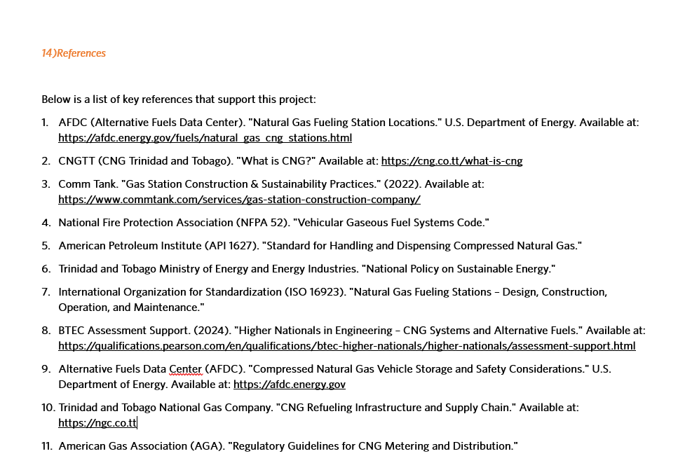

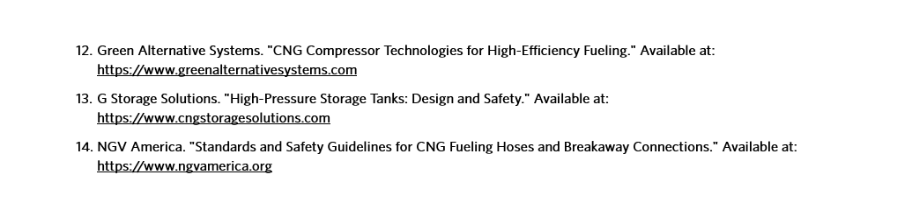

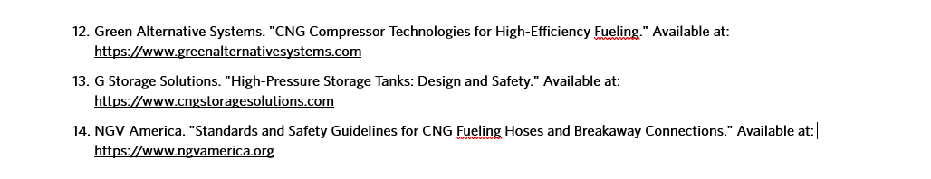

Appendix A

